Dan Greenawalt, Creative Director
Forza Racing Franchise

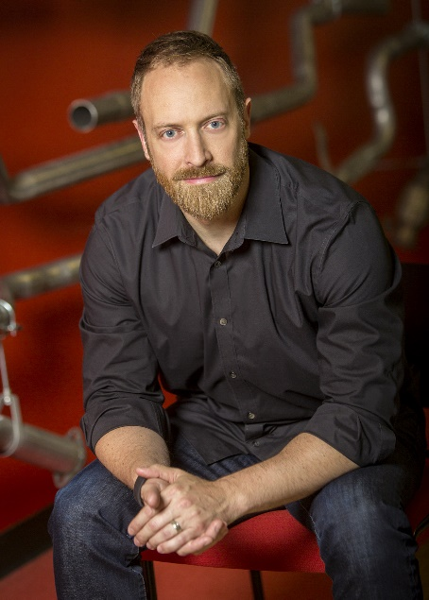
Dan Greenawalt is the Creative Director across the critically acclaimed Forza Racing franchise. His passions for gaming, technology and car culture allow him to inspire and coordinate the talented creative teams around the world that create Forza’s award-winning experiences. Greenawalt is driven to shape the future of automotive entertainment.

Though born in Pittsburg, Penn., Greenawalt grew up in the Seattle area. He holds a Bachelor’s Degree in Comparative Religion from The Colorado College. Greenawalt dedicated much of his life to the study of both competitive and traditional martial arts, earning a 2nd degree black belt in Hsing-I as well as an advanced teaching certificate in Jeet Kune Do.

Greenawalt’s love of gaming began early in life playing a friend’s NES (Nintendo Entertainment System) imported from Japan and eventually competing in “Street Fighter II” tournaments at local Seattle arcades. His introduction to the gaming industry came in 1997 when he joined Microsoft as a tester on “Inside Drive 2000” for PC. Over time, he transitioned into design on “Project Gotham Racing” which was developed in collaboration with Bizarre Creations. In 2002, Greenawalt and a small group founded Turn 10 within Microsoft Game Studios and began work on “Forza Motorsport” which launched on the original Xbox in 2005. His other past projects include versions of the “Motocross Madness” and “Midtown Madness” series on the PC.

His love of cars found a virtual outlet in the 90’s when he first played racing games such as “Test Drive”, “Need for Speed”, “Sega Rally”, “Gran Turismo,” and the groundbreaking “F355 Challenge”. Out of necessity and spurred by his experience in these early games, Greenawalt started his first project car in 1995, stripping and rebuilding a 1973 Toyota Corolla. Since then, he tuned a 1991 Mitsubishi 3000GT and a more heavily modified 2000 Audi S4 for track use. In 2015, he replaced his daily driver, a 2008 BMW M3 coupe, with a 2015 Selby GT350 (#0078).

Greenawalt currently resides in the greater Seattle area with his wife and twin sons.

