Dan Greenawalt, Creative Director
Turn 10 Studios

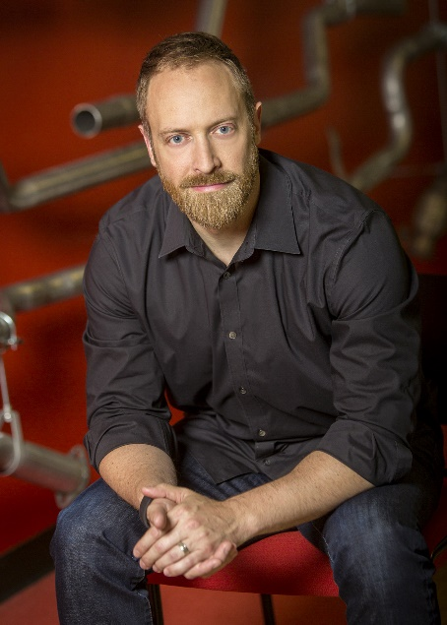
Dan Greenawalt is the Creative Director of the critically acclaimed racing franchise “Forza Motorsport.” His passion for vehicle dynamics and car culture allows him to lead the talented creative teams that make up Turn 10 Studios. Greenawalt and Turn 10 are driven to make experiences that shape the future of automotive entertainment.

Though born in Pittsburg, Penn., Greenawalt grew up in the Seattle area. He holds a Bachelor’s Degree in Comparative Religion from The Colorado College. Greenawalt dedicated much of his life to the study of both competitive and traditional martial arts, earning a 2nd degree black belt in Hsing-I and an advanced teaching certificate in Jeet Kune Do.

Greenawalt’s love of gaming began early in life playing an NES (Nintendo Entertainment System) imported from Japan and eventually competing in “Street Fighter” tournaments at local arcades. Greenawalt’s introduction to the gaming industry came in 1997 when he joined Microsoft as a tester on “Inside Drive 2000” for PC. Over time, he transitioned into design on “Project Gotham Racing” which was developed in collaboration with Bizarre Creations. In 2002, Greenawalt and a small group founded Turn 10 within Microsoft Game Studios and began work on “Forza Motorsport” which launched on the original Xbox in 2005. His other past projects include versions of the “Motocross Madness” and “Midtown Madness” series on the PC.

His love of cars found a virtual outlet in the 90’s when he first played racing games such as “Need for Speed”, “Sega Rally”, “Gran Turismo,” and the groundbreaking “F355 Challenge”. Out of necessity and spurred by his experience in these early games, Greenawalt started his first project car in 1995, stripping and rebuilding a 1973 Toyota Corolla for racing on dirt logging roads. Since then, he tuned a 1991 Mitsubishi 3000GT and later tracked a heavily modified 2000 Audi S4. He currently daily drives a lightly modified 2008 BMW M3 coupe.

Greenawalt currently resides in the greater Seattle area with his wife and twin sons.

