Dan Hurd
Design Director of Playful Corp
Director of Lucky's Tale and Super Lucky's Tale

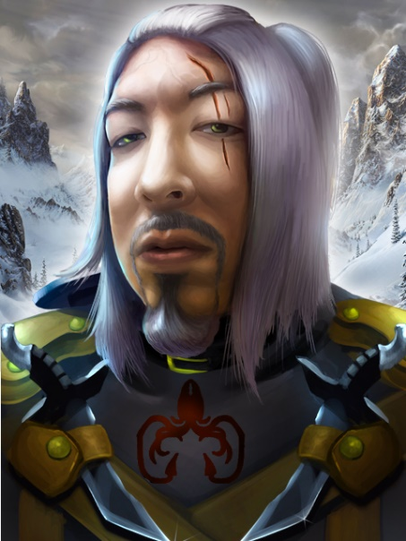
A crude homunculus, stitched together from assorted debris, Dan Hurd pantomimes his designs (with gnarled driftwood hands) for the Super Lucky's Tale team. They pretend to know what he’s saying and nod out of horror more than anything else.

Dan has previously worked on the original Lucky's Tale, Creativerse, Project Wonderland, and, in a previous life, several With Friends games, notably Hanging, Matching, and Gems, but he only designed the cool parts that you like, and none of the bad parts. ❤️.

Dan can be found on Twitter @thekrakenisme.

