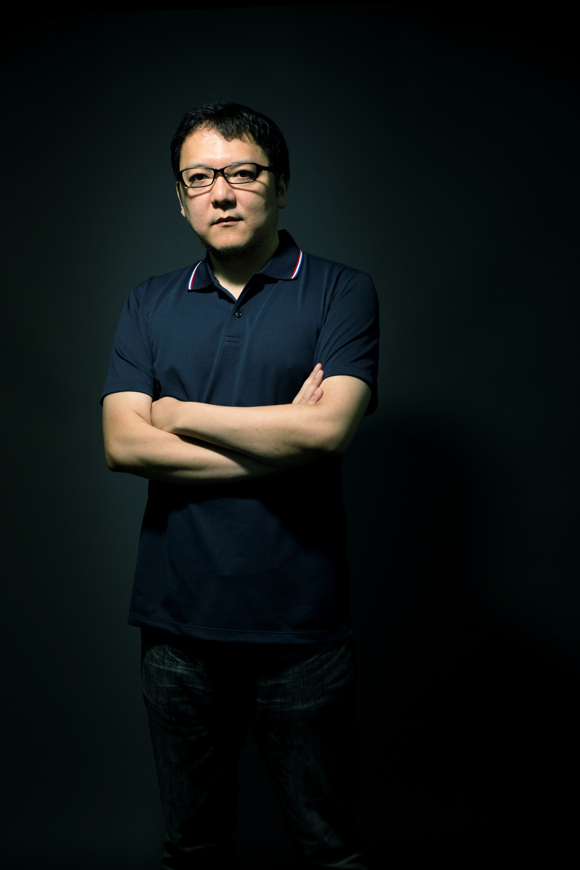- President and Game Director of FromSoftware Inc. Known for directing critically-acclaimed games in beloved franchises including Armored Core and Dark Souls.

