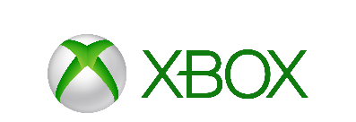

Mike Nichols
CMO for Gaming at Microsoft

As the CMO for Gaming at Microsoft, Mike Nichols leads teams dedicated to earning fans and for growing iconic products and franchises such as Xbox One, Xbox Live, Minecraft, Halo, Forza, Gears of War, Mixer and Xbox Game Pass.

Prior to assuming his role in early 2014, Mike was Corporate Vice President responsible for the global marketing of Bing where he led Microsoft’s search business to record growth. Earlier in his career, he helped design the product that would later be launched as Bing and played leading roles in the marketing of MSN, Windows and Internet Explorer.

A native of southern California, Mike attended the University of Michigan where he earned a business degree. He lives in the Seattle area, but still closely follows his beloved Michigan Wolverines and Los Angeles Lakers when not playing video games.

###

