Heartland Factsheet
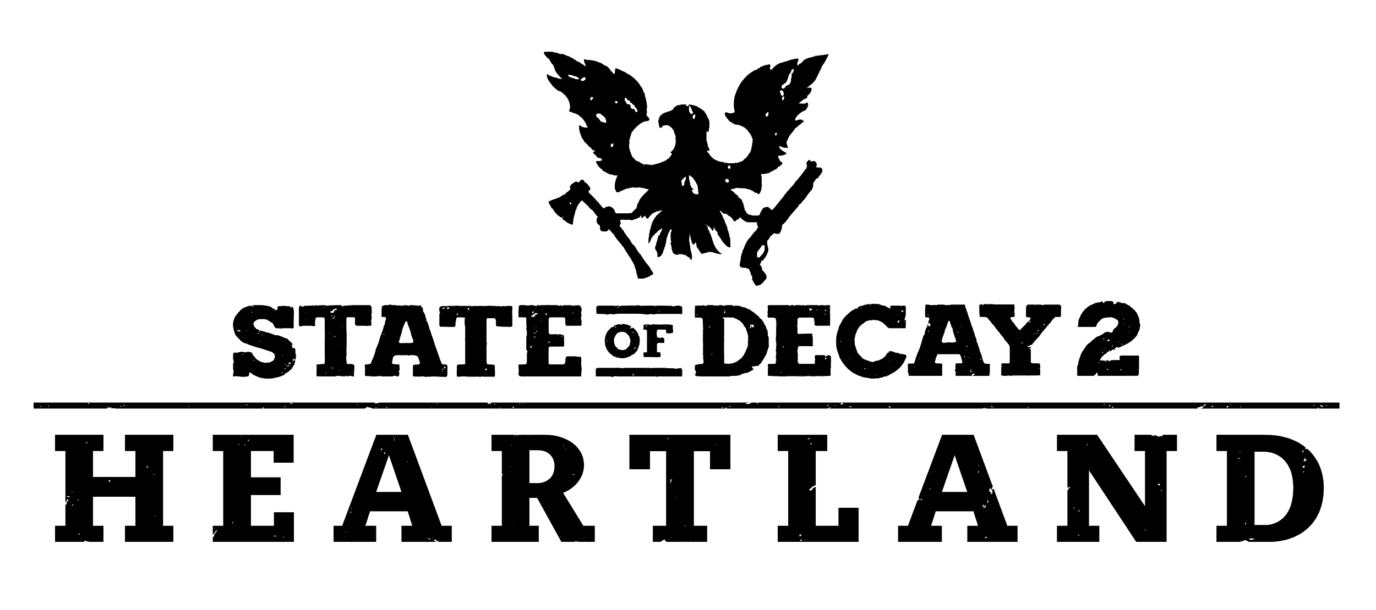

Welcome to Heartland.

State of Decay 2: Heartland features a return to Trumbull Valley in a new story-based adventure. Once the iconic site of the original State of Decay game, the towns of Spencer’s Mill and Marshall are now overrun with an advanced form of blood plague: a more aggressive and far deadlier version than exists anywhere else. Though it may be familiar territory to those who homesteaded here years ago, Trumbull Valley is packed with new dangers and stories for both existing and new fans to explore. As the game’s biggest update yet, this is the perfect time to join the over five million members of the “State of Decay 2” community.

The Past Is Never Dead.

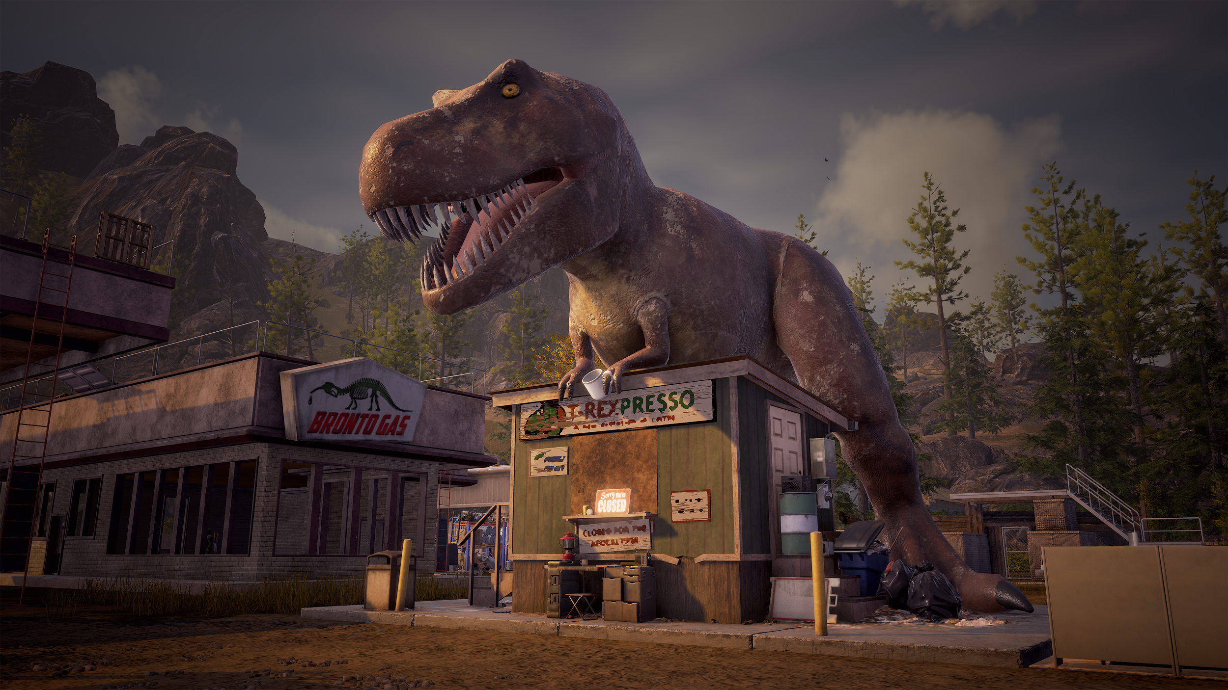
In Heartland, players choose from two sets of starting characters who have traveled to Trumbull Valley for different reasons. Both pairs of survivors are on a mission to find people important to them: characters who appeared in the original State of Decay. Players must also find and recruit crucial hand-crafted characters in order to build a strong community. They can also claim the beloved Jurassic Junction as their homesite and build the biggest base yet, blending nostalgia with new features.

Key Features

- New map! Explore Trumbull Valley, the site of the original State of Decay game
- Narrative-driven single-player adventure with branching storylines
- Choose your heroes! Heartland features two starting pairs of survivors:
  - Quincy, an ex-con and member of the Network, and his partner Helena
  - Larisse, the long-lost daughter of Mickey Wilkerson, and her aunt Fiona
- Custom characters including recruitable survivors
- Claim your base at Jurassic Junction, the largest homesite in the franchise
- All blood plague freaks! Blood plague screamers, ferals, juggernauts, and bloaters featuring deadly new attacks
- Over 8 hours of story-focused gameplay culminating in the Gauntlet, a grueling challenge that requires skill and strategy to overcome
- Provides answers players have wanted since the launch of the original game
- New achievements worth 500 Gamerscore

Available Now.

“Heartland” launches for all “State of Decay 2” players on June 9, 2019 included with Xbox Game Pass for PC and Console, and $9.99 on Xbox One and Windows 10. “Heartland” is an add-on to the “State of Decay 2” and requires the full game to be downloaded to take advantage of the update.

Heartland: How will you survive?

