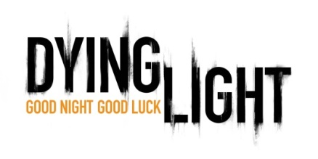
FACT SHEET

RELEASE DATE: 2014

PUBLISHER: Warner Bros. Interactive Entertainment
DEVELOPER: Techland
ESRB RATING: RP (M Anticipated)
GENRE: Survival Horror / First Person Action
PLATFORMS: Xbox One, PlayStation 4, Xbox 360, PlayStation 3, PC
PLAYERS: 1 – 4 (Co-Op Multiplayer)

PRODUCT OVERVIEW:

Dying Light is a first-person, action survival horror game set in a vast and dangerous open world. During the day, players traverse an expansive urban environment overrun by a vicious outbreak, scavenging the world for supplies and crafting weapons to defend against the growing infected population. At night, the hunter becomes the hunted, as the infected become aggressive and more dangerous. Most frightening are the predators which only appear after sundown. Players must use everything in their power to survive until the morning’s first light.

Good Night. Good Luck.

PRODUCT FEATURES:
- Survive the Night – During the day, players roam free and scavenge for supplies and weapons. But at night, the world undergoes a deadly transformation: the hunter becomes the hunted as the infected grow more aggressive and numerous, and something far more sinister awakens to stalk its prey.

- Free Running Movement – Whether tracking prey or escaping predators, Dying Light lets players swiftly navigate the world by seamlessly leaping between buildings, grappling up walls and pouncing on unsuspecting enemies.

- Welcome to the Quarantine – Dying Light is set in a vast open world, delivering expansive and varied environments, a wide variety of enemy classes and a hopeless tale of survival where resources are scarce and the infected are not the only threat.

- Brutal Melee and Ranged Combat – get up-close using a variety of light and heavy weapons including knives, bats, axes, sledgehammers and more exotic weaponry or utilize guns and other firepower to take down enemies from a distance.

- Choose Your Play Style – Dying Light features four playable characters that can be fully customized and upgraded to match any play style.

- Craft Your Weapon – Why use a wrench when you can use a wrench wrapped in electrified barb wire? Dying Light’s sizeable crafting system enables players to create a slew of new, more potent weapons and equipment, as well as specialized ammunition.

- Breathtaking Visuals and Gameplay – Dying Light is the first game powered by Chrome Engine 6, a cutting edge incarnation of Techland’s proprietary technology, designed from the ground up for the new console generation, DirectX 11 and other advanced solutions.
CONTACTS:  Mark Margolis  Warner Bros. Interactive Entertainment  mark.margolis@warnerbros.com  818.977.1787 | Steve Hahnel  fortyseven communications  shahnel@fortyseven.com  212.391.4707

