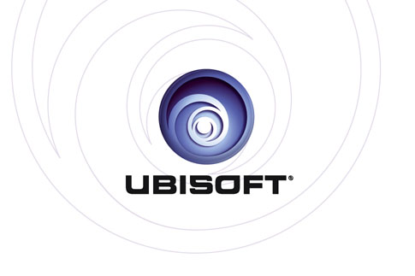

PRESENTS:

Assassin’s Creed® Unity

Product Description

Paris, 1789. The French Revolution turns a once-magnificent city into a place of terror and chaos. Its cobblestone streets run red with the blood of commoners who dared to rise up against the oppressive aristocracy. As the nation tears itself apart, a young man named Arno will embark on an extraordinary journey to expose the true powers behind the Revolution. His pursuit will throw him into the middle of a ruthless struggle for the fate of a nation, and transform him into a true Master Assassin.

Introducing Assassin’s Creed® Unity, the next-gen evolution of the blockbuster franchise powered by an all-new game engine. From the storming of the Bastille to the execution of King Louis XVI, experience the French Revolution as never before, and help the people of France carve an entirely new destiny.

Key Features

- A UNIQUE CO-OP EXPERIENCE YOU MUST PLAY TO BELIEVE
In addition to an epic single-player campaign, join with up to three friends online and experience the open world of 18th-century Paris. Pull ambitious heists and take part in unique narrative-driven missions designed exclusively for co-op play. Sabotage an execution. Protect an emperor. Assassinate a Templar agent. Victory won’t be easy; you and your lethal band must rely on communication, coordination, and diverse skills to accomplish your missions, then vanish into the shadows.

- A RUTHLESS NEW HERO FOR A BRUTAL WORLD
Play as Arno, an entirely new breed of Assassin, and take down your prey with a range of new weapons such as the Phantom Blade, a hidden blade with crossbow capabilities.

- BRAND-NEW PARKOUR, COMBAT, AND STEALTH GAMEPLAY
Enjoy an unprecedented degree of freedom and control over your Assassin.
  - Full motion control with new parkour mechanics for free running up, across, and down city walls and buildings.
  - A reinvented fighting system provides a richer combat experience based on skill, timing, and flow.
  - Enhanced stealth gameplay, including a new stealth mode, cover system, and crowd-manipulation techniques. Stay hidden, stalk your prey, and strike without warning.

- DEEP CUSTOMIZATION MECHANICS TO CRAFT YOUR OWN MASTER ASSASSIN
Craft a unique play style by choosing weapons, gear, outfits, and specialized skills. Mix and match from hundreds of possible combinations and build your stealth, fighting, and navigation abilities from a new, expansive skill tree. Become the ultimate Master Assassin.

- DISCOVER REVOLUTIONARY PARIS, BROUGHT TO LIFE AS NEVER BEFORE
Carve through the stunning full-scale open world city, a feat only made possible through the power of an all-new game engine.
  - Explore detailed building interiors and discover secret catacombs and sewers.
  - Embark on ancestral missions, treasure hunts, murder mysteries, contracts, and more. The city is packed full of activities that will captivate for hours.
  - Witness the chaos of the French Revolution firsthand and become immersed in the realistic, systemic crowds of up to 5,000 AI-driven characters.

Product Specifications
Publisher: | Ubisoft®
Developers: | Ubisoft Montreal / Toronto / Quebec / Annecy / Bucharest / Kiev / Shanghai / Singapore
Release Date: | Holiday 2014
Genre:  Platforms: | Action/Adventure  Xbox One, PlayStation®4 system, and PC
ESRB: | Rating Pending
URL: | assassinscreed.com
© 2014 Ubisoft Entertainment. All Rights Reserved. Assassin’s Creed, Ubisoft, and the Ubisoft logo are trademarks of Ubisoft Entertainment in the US and/or other countries.

