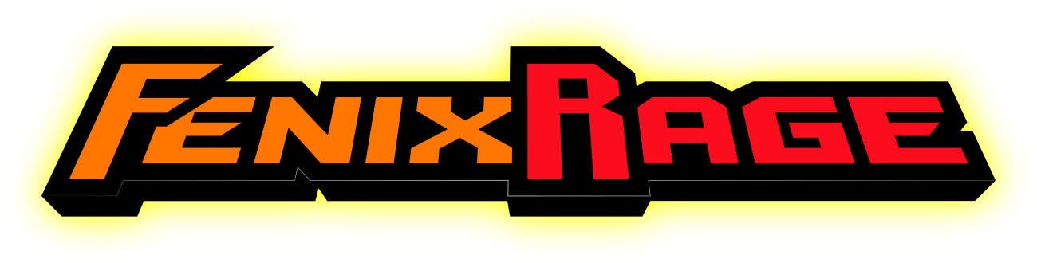
FENIX RAGE – FACT SHEET
“Get the cookie.”

Game: Fenix Rage (www.fenixrage.com) Platform: PC, Xbox One
Developer: Green Lava Studios (www.greenlavastudios.com) Launch: Late Summer 2014 / Q1 ‘15
Genre: 2D Platformer Price: $14.99

Game Description

Do you enjoy a challenge in gaming? Are you a fan of games that reward your prowess and skills while punishing those with less talented thumbs? Do you like cookies? If you answered yes to any of these questions, then Fenix Rage may be just the thing for you and your discerning videogame palate.

From Green Lava Studios, Fenix Rage is an inspired, frenetically-paced, challenging and aggressively addicting 2D platformer that will keep your palms sweaty, your thumbs fatigued, and your wits sharp. Gamers take on the role of Fenix, whose village is decimated by a huge explosion, leaving only two survivors – Fenix and Oktarus, a mysterious figure who manages to elude Fenix’s best efforts at capture.

Fenix Rage is all about hundreds of lightning-paced levels that will test your ability to jump, and dash your way through a maze of dangerous obstacles, all in an effort to track down the shadowy Oktarus through several worlds…and of course, to collect each level’s cookie! You’ll struggle mightily to achieve the best rankings in the best time with the fewest deaths to rub in your friends’ faces. Loads of different enemies, slick retro-inspired music and fantastic environments, and the need to master lots of varying platforming tactics await you…are you up for the challenge?

Game Features

- Nine varied and vastly unique worlds to traverse and conquer, each with dozens of increasingly difficult levels
- Over 200 total levels, each with varying enemies and obstacles to overcome, as well as a cookie to collect
- Rapid-fire gameplay style means no downtime between attempts and deaths (and you WILL die…a lot)
- Addictive nature of play that demands your absolute BEST platforming skills to achieve the best ratings per level
- Stylized 2D art style compliments the original electronic soundtrack that varies with each world

About Green Lava Studios

Green Lava Studios prides itself on combining technology, new gameplay experiences, inventive storytelling, and meaningful messages into completely unique and compelling interactive entertainment. Hailing from lovely Costa Rica, Green Lava Studios consists of an experienced four-year team whose mission is to create fun, memorable, and captivating games for the whole world to enjoy. With several successful titles already under its belt (including “Bonfire Trail”, winner of the “Square Enix Latin America Game Contest Finalist Award (3rd Place)” in 2012), Green Lava is one of the brightest young independent developers in South America.

Similar Titles

Super Meat Boy, Sonic the Hedgehog, Cloudberry Kingdom, n+, Flappy Bird

