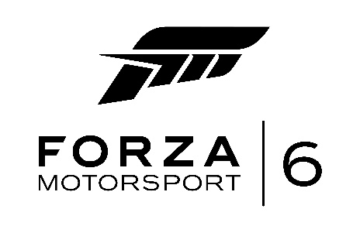

“Forza Motorsport 6”

Fact Sheet

October 2015

Title: “Forza Motorsport 6”

Availability: Sept. 15, 2015 Americas and Asia (Except Japan & China)

Sept. 17, 2015 Japan

Sept. 18, 2015 Europe, Middle East, Africa

Publisher: Microsoft Studios

Developer: Turn 10 Studios

Format: Blu-ray and digital download for Xbox One; Xbox Live-enabled

ESRB Rating: E for Everyone

Pricing: Standard Edition: $59.99, £49.99, €69.99
Deluxe Edition: $79.99, £65.99, €89.99
Ultimate Edition: $99.99, £81.99, €109.49

Product
Overview: Experience unrelenting action in the most beautiful and comprehensive racing game of this generation. Collect, customize, and race over 460 Forzavista™ cars*, all with working cockpits, opening doors and full damage. Compete in epic 24-player races across 26 world-famous locales. Master wet weather and night racing on your road to victory.

Features: As Real As It Gets
- Stunning realism at 1080p resolution and 60 frames per second.
- The danger and intensity of night racing comes alive under the stadium lights of Daytona and in the utter blackness of Le Mans' back stretch.
- Experience the immersion of racing in the rain as working wipers barely clear the spray and tires hydroplane across physically-based 3D puddles.

Ultimate Car Fantasy
- Collect and race over 460 Forzavista™ cars, all featuring working doors, cockpits, damage and customization.
- Tour 26 world-famous locales, including 10 newly captured tracks, all built from the ground up for Xbox One.
- Celebrate the thrilling world of motorsport, reliving classic races and epic rivalries in the all-new 70+ hour career mode.

Never Race Alone
- No two races are the same in the home of the greatest racing, tuning and painting community in gaming.
- New Forza Race Leagues and online spectating combine to give everyone the thrill of professional competitive multiplayer* racing.
- Compete in epic 24-player races in single player against cloud-powered Drivatar™ opponents and on Xbox Live on dedicated servers.

Assets
Assets for “Forza Motorsport 6” are available on Xbox Wire.

About Forza Motorsport
Welcoming racing gamers of all types, Forza Motorsport games combine unprecedented visuals with the industry’s leading simulation engine, giving everyone the opportunity to truly feel what it’s like to own, race and customize the cars of their dreams.

Forza Motorsport is developed by Microsoft’s award-winning game developer Turn 10 Studios. “Forza Motorsport 5: Game of the Year Edition” and “Forza Horizon 2” are available now for Xbox One.

More information about the Forza Motorsport franchise is available at http://www.forzamotorsport.net.

About Xbox
Xbox is Microsoft’s premier gaming and entertainment brand created by gamers for gamers on Xbox One, Xbox 360 and Windows 10 devices. Xbox delivers the best games and greatest social gaming network with Xbox Live. More information about Xbox can be found online at http://www.xbox.com.

About Microsoft
Founded in 1975, Microsoft (Nasdaq “MSFT”) is the worldwide leader in software, services and solutions that help people and businesses realize their full potential.

The information contained in this fact sheet relates to a pre-release product that may be substantially modified before its first commercial release. Accordingly, the information may not accurately describe or reflect the product when first commercially released. This fact sheet is provided for informational purposes only, and Microsoft Corp. makes no warranties, express or implied, with respect to the fact sheet or the information contained in it.

For more information, press only:
Shirley Kim, Assembly, (206) 268-2204, shirley.kim@assemblyinc.com
Sarah Conde, Assembly, (206) 268-2271, sarah.conde@assemblyinc.com

Online multiplayer requires Xbox Live Gold membership (sold separately). Some content including some tracks and cars may require download from Xbox Live (ISP fees apply).

