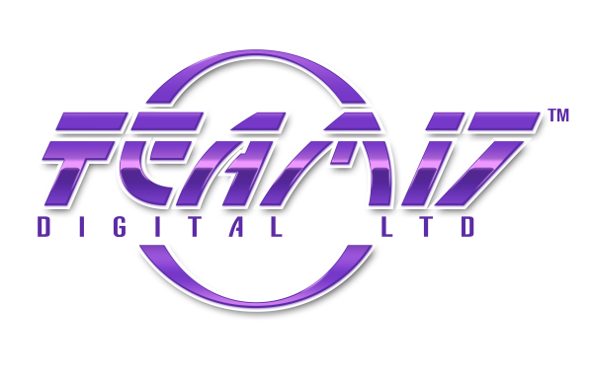

Overruled!

FACT SHEET

Publisher: Team17 Digital Ltd

Developer: Dlala Studios

Release Date: Coming 2014

Genre: Action, Indie, Brawler

Players: 1-4 players, local and online multiplayer

Brief Game Description:
Overruled! is a multiplayer brawler like no other - players change the rules as they play, directly influencing the dynamics and direction of combat.

Choose from a diverse cast of characters and challenge up to three friends to a battle with both local and online multiplayer! All you have to do to win is score the most points by the end of the game. But the rules are yours to play with and with over 25 change ‘em up cards, you’ll never know how the battle will go and no game is ever the same!

Key Features:
- Unique Change ‘Em Up Cards! Over 25 different change ‘em up cards to play. Change ‘em up cards change the conditions of gameplay. One minute you could be playing Headhunter but then your opponent could pick up and play a Fire Tag card or Race card! Is your opponent on the verge of death? Play the 10 second respawn card to keep them out of the battle longer while you clean up all the points!
- 6 Different Game Types. Including King of the Hill, Swag Bag, Fire Tag, Smash ‘n’ Grab, Headhunter and Race.
- Crazy characters featuring unique voice overs. Inccluding voice overs from YouTubers iBallisticSquid, Miss Mousie Mouse and DaSquirrelsNuts.
- Multiplayer fun! Enjoy hilarious multiplayer battles with up to 3 friends either online or locally. With Overruled! each game is always different!
Race
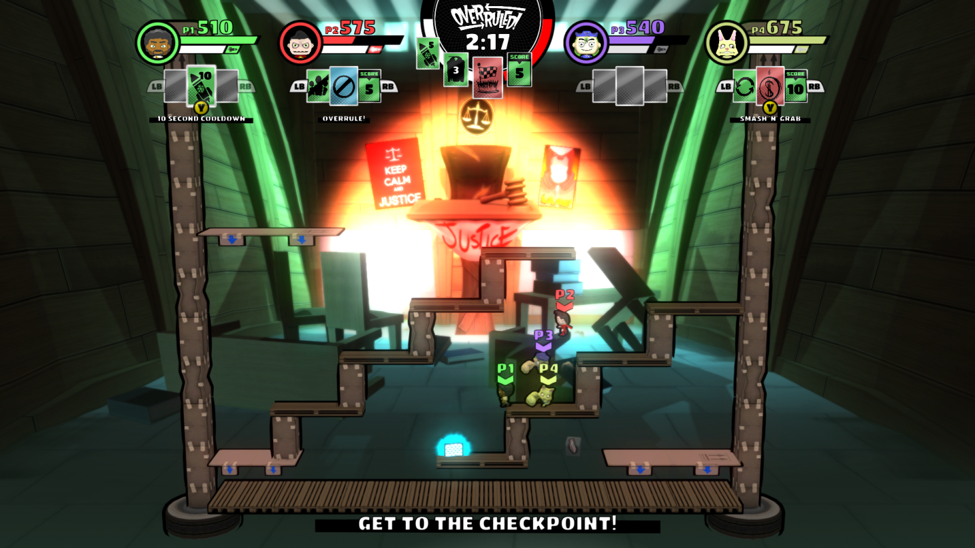

Swag Bag
