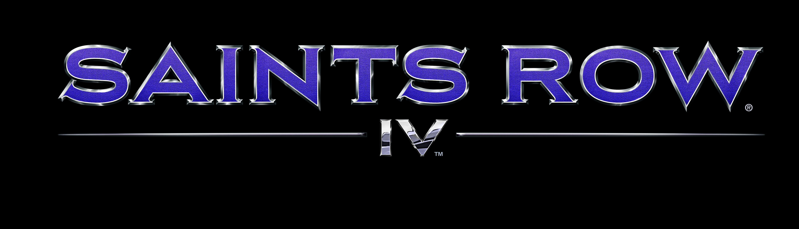

Developer: Volition
Publisher: Deep Silver
Platforms: Xbox 360 / PS3 / PC
Genre: Open World Action
Launch Date: August 20, 2013
Age Rating: expected M
Players: 1-2 online only co-op
SRP: $59.99 consoles / $49.99 PC

Description:
Following their involvement in <REDACTED TO PREVENT SPOILERS>, the Saints were once again thrust into the lime light: only this time they weren’t viewed as dangerous criminals; they were heralded as patriots. Riding their wave of popularity, The Leader of the Saints decided to run for the highest office…and won. Now the President of the United States, the boss has gone from the crack house, to the penthouse, to the White House.
But all is not well. Despite eliminating the deficit, ending world hunger, and successfully lobbying to have pole dancing added as an Olympic sport…something dark is looming: the arrival of the Zin Empire.
Lead by the erudite and egomaniacal Zinyak; the Zin brazenly attack Washington DC, abducting the President and his entire cabinet. Their goal was to imprison the captives in a virtual prison to break down their will…but they never realized that the individuals they brought onto their ship weren’t fat cat politicians: they were the most dangerous men and women on the planet.
Features:
The American (Fever) Dream – Play as the President of the United States in a story that spans countries, space, and time. Saints Row IV is to Saints Row: The Third what Saints Row: The Third is to Do The Right Thing. You’re not ready.
Super Hero-in-Chief – Leap over buildings. Kill people with your mind. Run through tanks. Those are some of the most mundane powers you will wield in your quest to stop an alien menace hell-bent on destroying the Earth.
Alien Toys of Destruction - Wield an impressive array of alien vehicles and weapons… FOR SCIENCE!
Custom Weapons, Custom Mayhem– You’ve customized your character. You’ve customized your clothes. Now you can complete the look with our all new weapon customization system. Turn traditional weapons into exotic conversation pieces!
Dynamic Duo- Seamless drop-in, drop-out co-op, a Saints Row standard, improved. The only thing better than one malicious super-powered President is two.

