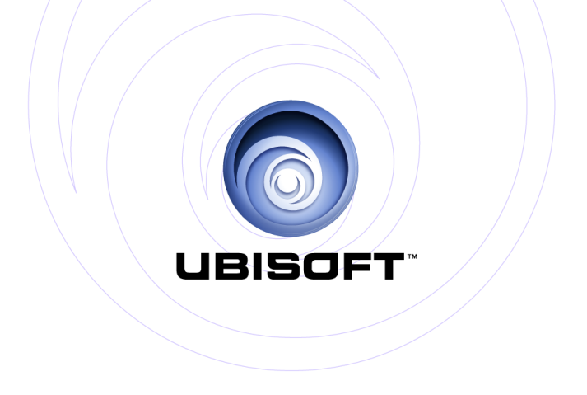

PRESENTS:

SHAPE UP
Play hard! Get fit!

More Fun. More Results.

Product Description:

Here’s a fun fact for you: when you’re having fun, you actually get a better workout because you work out harder.

Tired of going to the gym and repeating the same boring workout routine? So are we. That’s why we created Shape Up.

Shape Up is the game that proves when you have fun, you get better results. Shape Up features unique and entertaining 90 second challenges that turn the chore of working out into a fun experience.

Shape Up‘s next-generation camera technology means that you’ll never have to play solo. Record your workouts with the rePLAY system to challenge yourself, your friends or play against unexpected characters in-game.

Shape Up will capture your workouts and calories burned so you can track your results. You can also choose between cardio or strength exercises for a workout to match your mood. And if you live life on-the-go, there’s a mobile app too, so you can get fit right from your phone.

Simple. Fun. Effective. Take the work out of the work out, and try Shape Up for yourself. The future of home videogame workouts is finally here.

Key Features

- Unexpected Workout Exercises
Tired of the same old workout routine? That’s why we’ll force you to punch out asteroids for a cardio workout or squat your way to the moon for a deep quad burn. Oh, and you can bench-press an elephant too.

- Play A Whole Bunch Of Different Ways
Target specific muscle groups in rapid-fire, 90-second training bursts. Take on a four-week, goal-oriented quest mode, or challenge your friends online for ultimate bragging rights.

- Kinect sensor
Play as yourself on screen using Microsoft’s new Kinect technology. Full body tracking enables Shape Up to get a precise read on your movements.

- You Vs. You
Or play with other people. It’s totally up to you. With rePLAY motion capture and storage technology, you can record a workout and compete against yourself, or try to exert your physical will over the Internet, by sharing with friends.

- Beyond the Console
Use our personal trainer web service or our companion mobile app to create custom programs, monitor your game progress and manage your diet.

Game Details
Publisher: | Ubisoft®
Developer: | Ubisoft Montreal
Release: | November 14th 2014
Category: | Extraordinary Home Fitness
Rating: | Pending (PEGI 7)

Platforms: | Xbox One

