The Escapists

FACT SHEET

Publisher: Team17 Digital Ltd

Developer: Mouldy Toof

Release Date: 2015

Genre: Adventure, Indie, Simulation, Strategy

Players: Single player

Brief Game Description:
The Escapists is a time management prison escape game that gives you the 'freedom' to live the life of a prison inmate, ultimately plotting and pulling off a daring escape!
To escape you'll have to work around the strict prison schedule as best you can to avoid any unwanted attention from the guards. Craft weapons and tools from the unique items you will find, or steal, around the prison but beware of cell shakedowns! Perform “favour” quests for your in-mates or apply for a job in order to make the money you’ll need to obtain those vital supplies! Discover and navigate multiple escape routes! All that stands between you and your freedom is a perfectly executed escape plan.
Key Features:
- Prison Jobs! Different prison opportunities to sink your teeth into… If you have the knowledge to earn and hold down these employment paths of course! Jobs include laundry work, woodwork, metalwork and cook.
- Favours! Not earning enough from your job or unable to keep one down? Why not take on one of the various favour types offered up by the inmates as an alternative income generator.
- Crafting! There are 100+ unique Items for you to seek out, some of which can be used to craft useful items with. Craft comb blades, fake vent covers, sock maces, contraband pouch and bed dummies!
- Different Prisons. Multiple themed prisons for you to try your hand at escaping from!
- Multiple Escape Routes. Will you work on collecting the items you’ll need to craft a shovel to start digging out? Don’t forget the supports and the quandary of what to do with all that soil…

Or will you start hacking away at that pesky vent cover and attempt the hazardous prison roof? Watch out for the guard tower snipers!

Attend roll calls
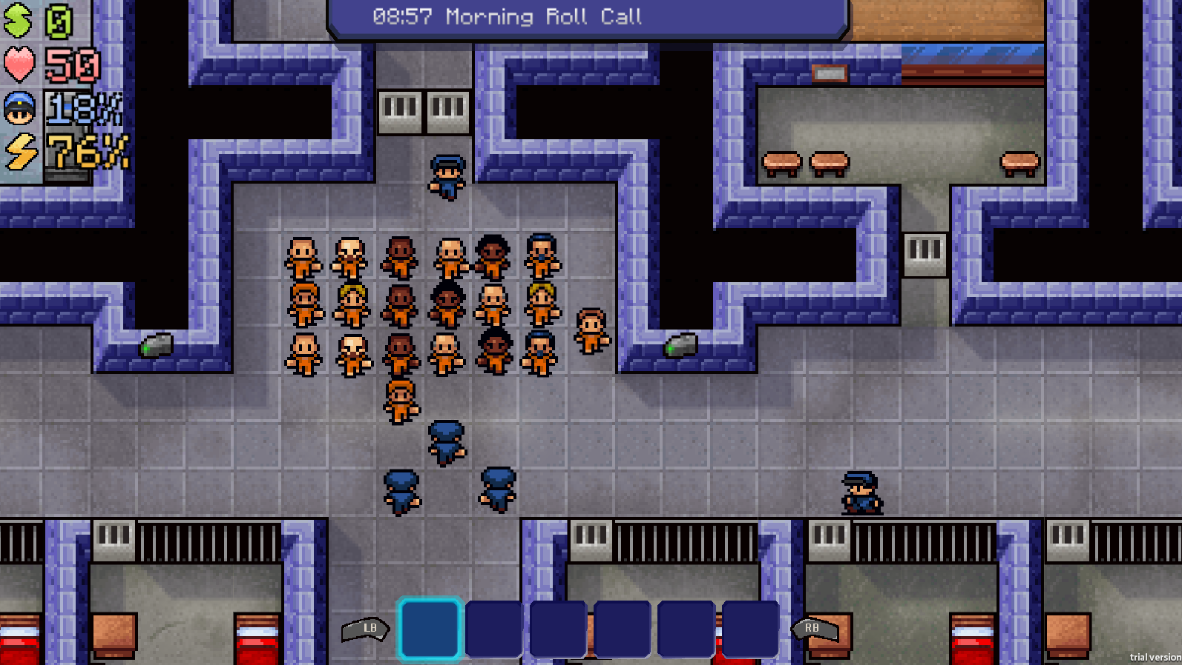

Improve your character stats! You’ll hold your own much more in any prison fights and be able to apply for new job roles.
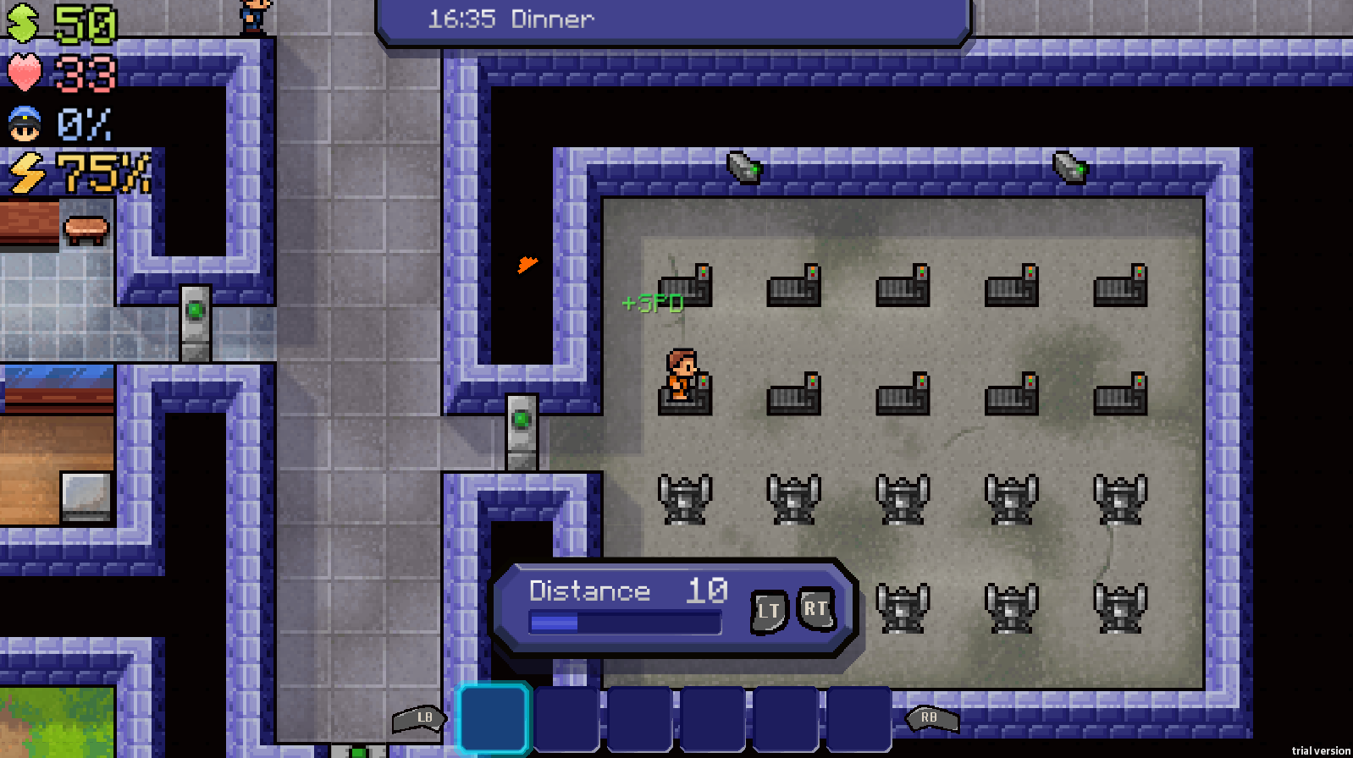

Get a prison job to earn some cash!
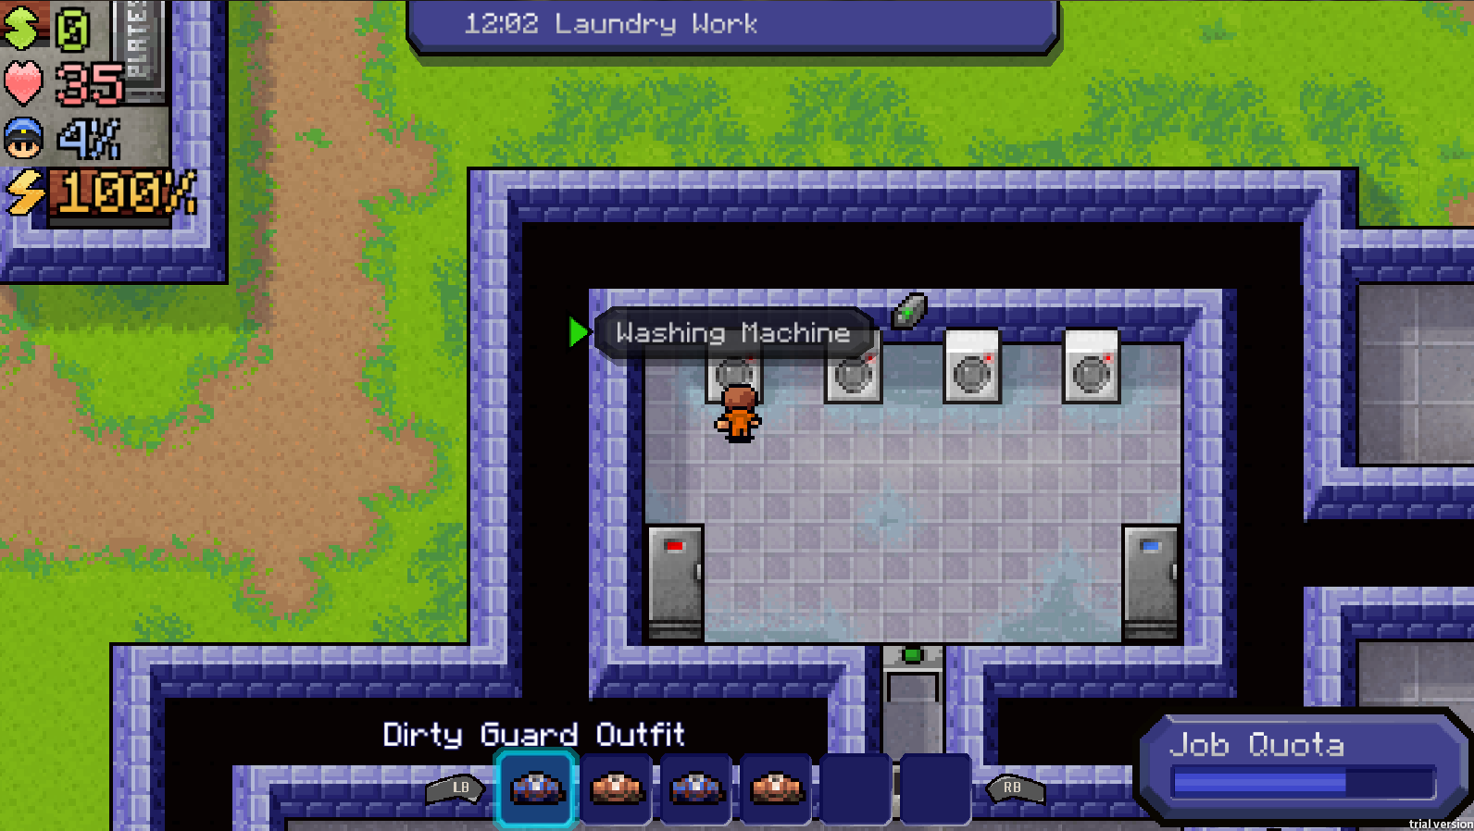

Follow the rules or play it your own way!
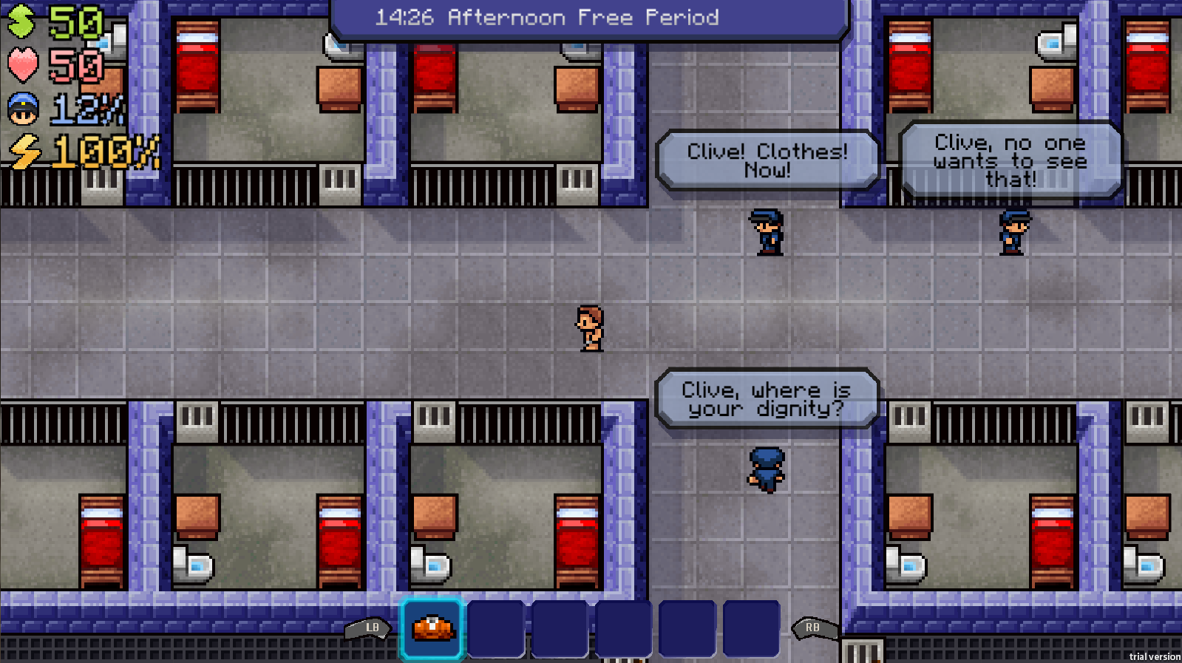

Craft vital items for your escape
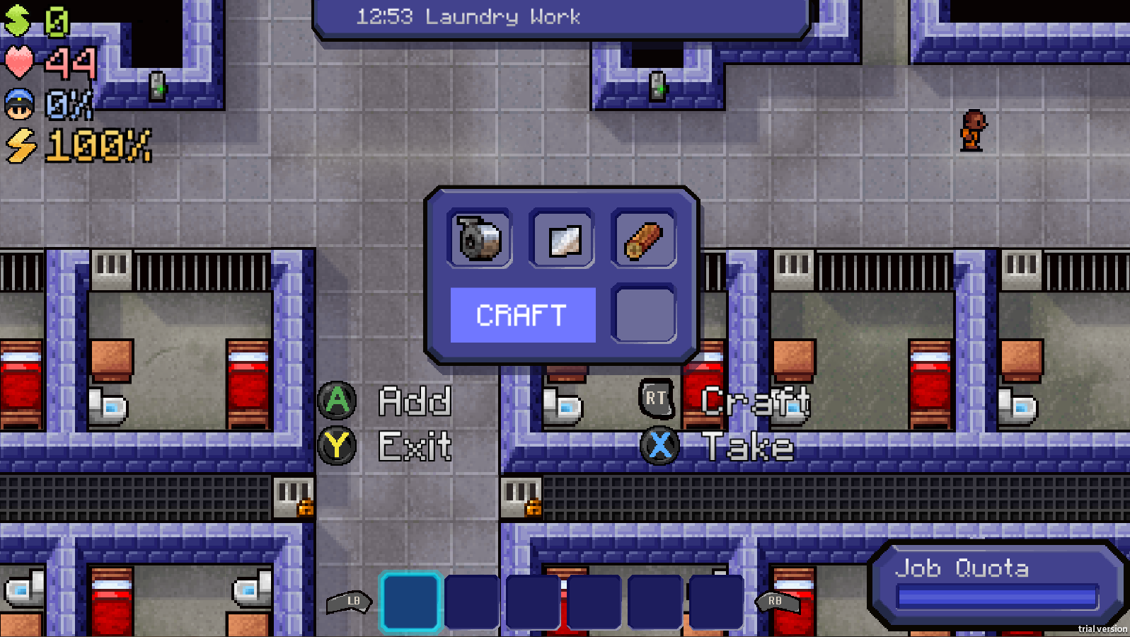

& ultimately work on your escape plan!
