Vehicle | Holden Commodore VF
Chassis | V8SC Design, built by Triple Eight Engineering
Engine | KRE developed 5.0 Litre naturally aspirated V8 Holden 308 cast iron block and CNC aluminium heads
Power | Estimated 640 bhp - limited to maximum 7,500 RPM
Electronics | Motec supplied M800 Engine Management System as well as Power Distribution module, data recording, displays and Video Capture system
Transmission | Control Albins ST6 6 speed sequential Transaxle with integrated spool differential.
Axles | Control parts from Race Products
Clutch | Triple plate carbon 7 and ¼ inch
Suspension | Front  Triple Eight Race Engineered double wishbone suspension with adjustable damper and cockpit adjustable front anti-roll bar.  Rear  Independent Rear Suspension manufactured at Triple Eight with adjustable damper and cockpit adjustable anti-roll bar.
Brakes | Front  AP Racing 6 piston calliper, 395mm ventilated discs  Rear  AP Racing 4 piston calliper, 355mm ventilated discs
Shock Absorbers | Front and Rear Sachs developed dampers supplied by Triple Eight
Wheels | Control Rimstock 18” x 11” forged aluminium
Tyres | Dunlop 18" controlled tyre, Hard and Soft compound as well as wets
Steering | Control Collapsible Steering column from Woodward
Pedal Box | Triple Eight Race Engineering designed and built
Windscreen | Polycarbonate
Fuel System | Carbon Fuel Cell as Well as 75Lt Sprint tank and 120Lt Enduro Tank Supplied by Premier Fuel Systems
Weight | 1400KG (With Driver)
Top Speed | 298 kph
0-100km/h | 3.3 secs
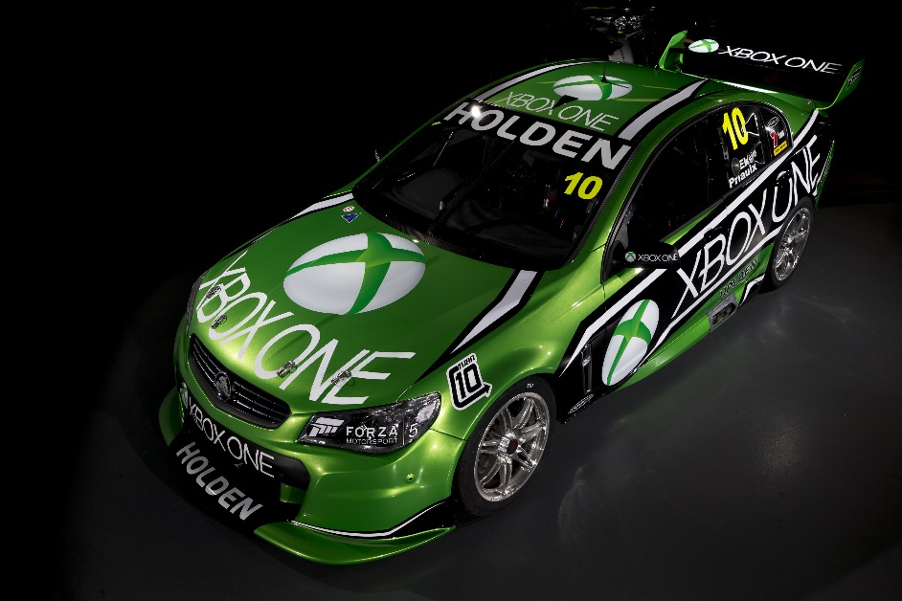
XBOX ONE RACING – VF HOLDEN COMMODORE

