XBOX ONE RACING – COMBINED BATHURST EXPERIENCE

TRIPLE EIGHT ENGINEERING STATS
First Bathurst Start | 2003 | 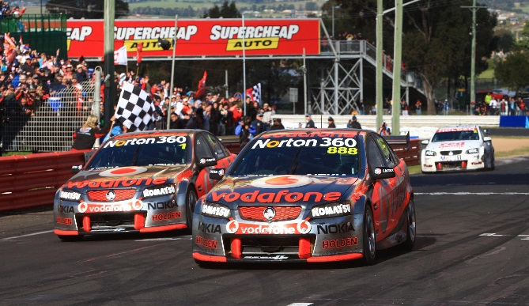
Bathurst starts | 20
Bathurst wins | 5  (2006, 07’, 08’, 10’, 12’)
Bathurst Podiums | 9
Bathurst Poles | 1  (2005)
Top 10 Shootouts | 12
Bathurst Finishing rate | 16 from 20 starts = 80%
Note: Based on 2 entries each year

MARK SKAIFE STATS
First Bathurst Start | 1987 | 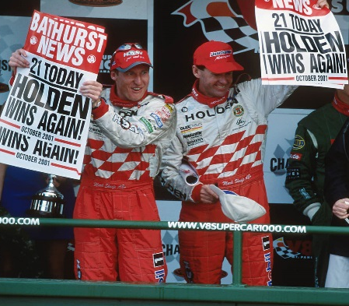
Bathurst starts | 25
Bathurst wins | 6  (1991, 92’, 2001’, 02’, 05’, 10’)
Bathurst Podiums | 10
Bathurst Poles | 5  (1991, 97’, 98’, 2002, 06’)
Top 10 Shootouts | 16
Bathurst Finishing rate | 19 from 25 starts = 76%

ANDY PRIAULX STATS
First Bathurst Start | 2002 | 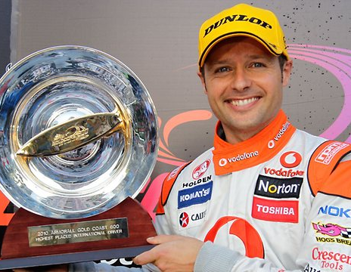
Bathurst starts | 3
Bathurst wins | 0
Bathurst Podiums | 0
Bathurst Poles | 0
Top 10 Shootouts | 0
Bathurst Finishing rate | 1 from 3 starts = 33%
Highest Bathurst finish | 12th in 2009
V8 Supercar Podiums | 1 (2010 Gold Coast 600)

